Huisje 1: The Cloud Cottage ☁️🏡

**Raspberry IP**:   
**Home Assistant URL**:   
**Wifi**: Itenium2025 / DenBerg1840! (Gateway: 172.16.10.254, Subnet: 255.255.25**2**.0)

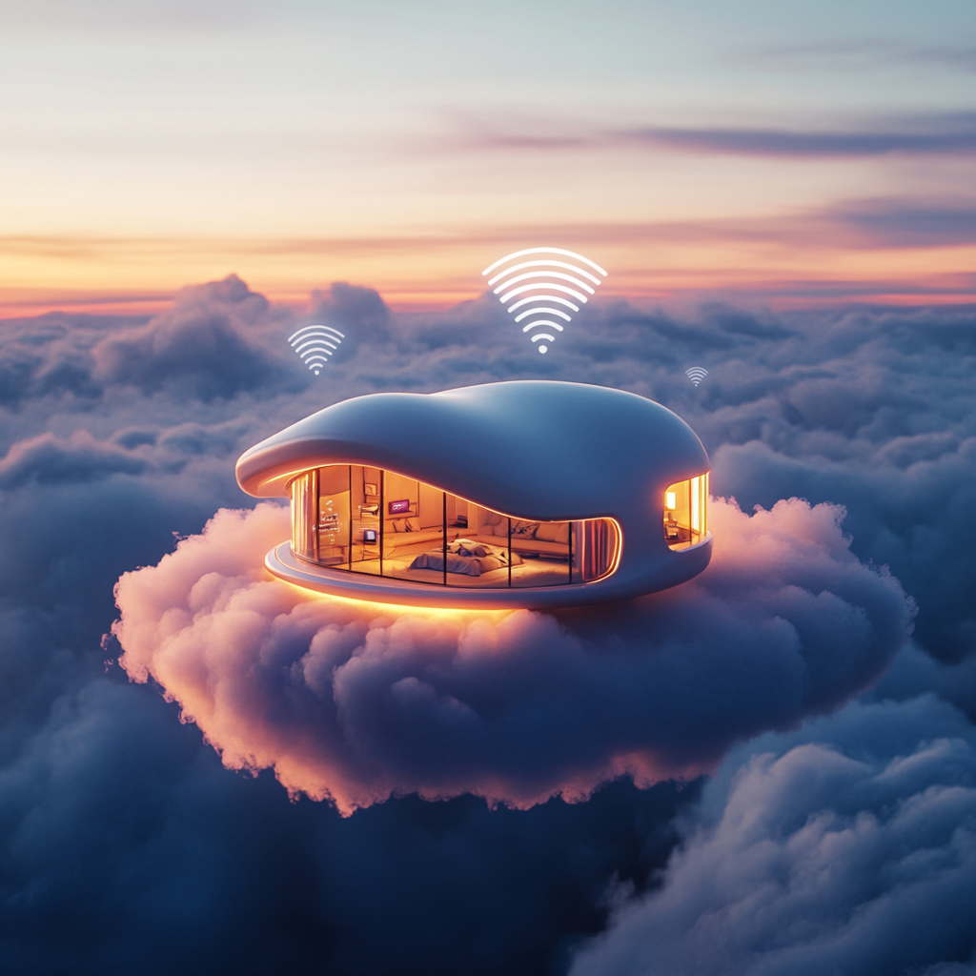

Huisje 2: Casa del Lag 🏠💨

**Raspberry IP**:   
**Home Assistant URL**:   
**Wifi**: Itenium2025 / DenBerg1840! (Gateway: 172.16.10.254, Subnet: 255.255.25**2**.0)

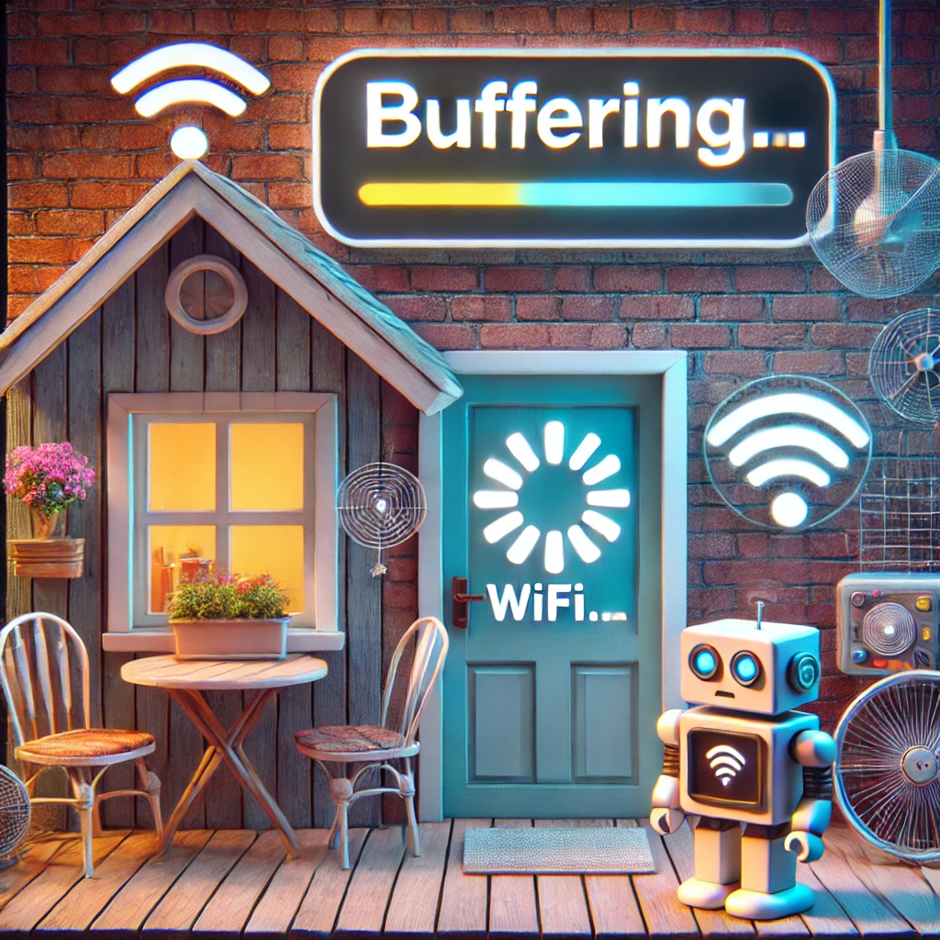

Huisje 3: The Reboot Ranch 🔄🐴

**Raspberry IP**:   
**Home Assistant URL**:   
**Wifi**: Itenium2025 / DenBerg1840! (Gateway: 172.16.10.254, Subnet: 255.255.25**2**.0)

